Milk Creek Mercantile Co.

Civil War Sutler
PO Box 898
Mulino, OR 97042
Phone: (503) 829-3678
Fax: (503) 829-7220

Mail In Order Form

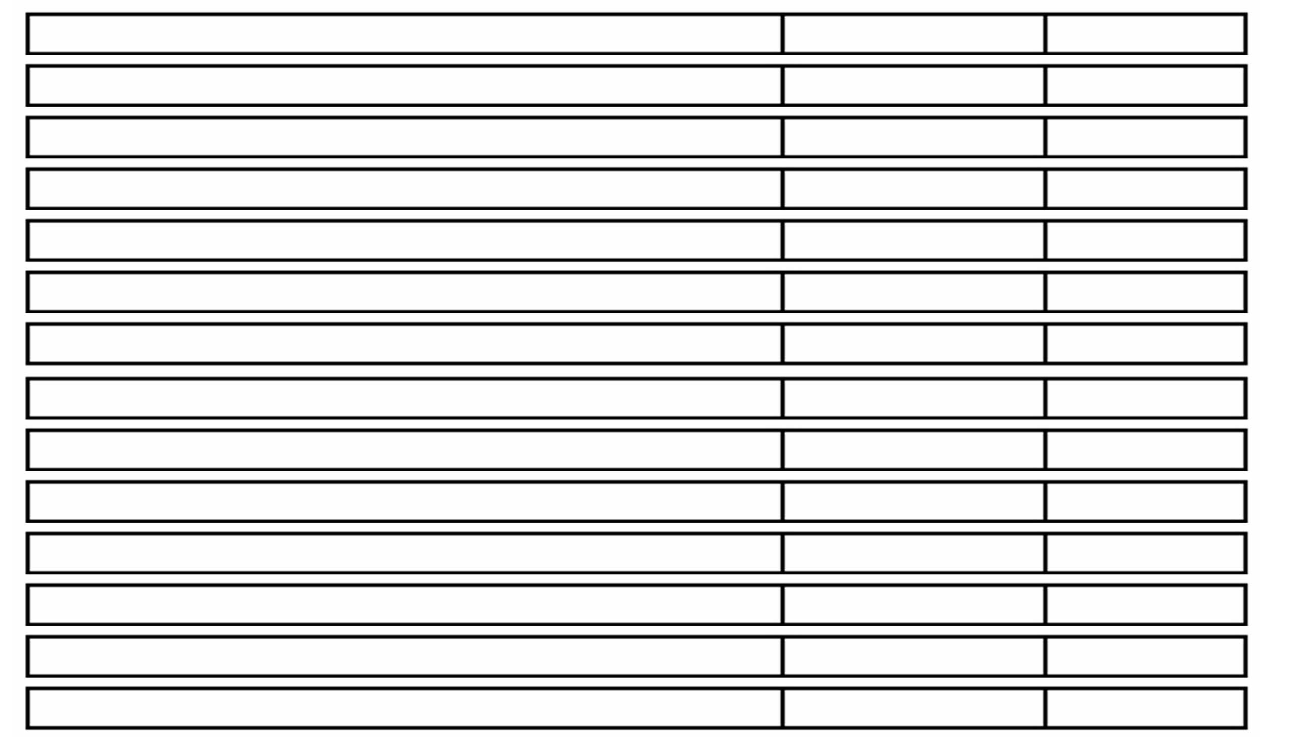
Item Amount Price

SUB TOTAL $__________

TAX $__________

SHIPPING $__________

TOTAL $ ___________

